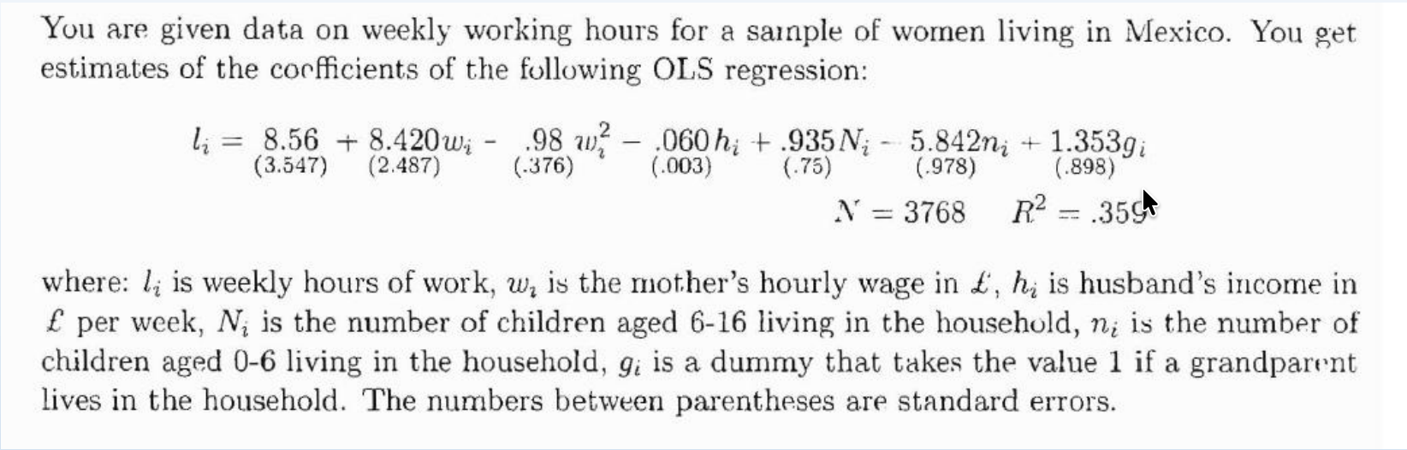

Selection bias because the sample is unrepresentative of the whole woman population
12.45
Backward bending curve, find the tipping w point then point out where is the income and substitution effect
Depends on the mother’s income if low then substitution effect if high then income effect

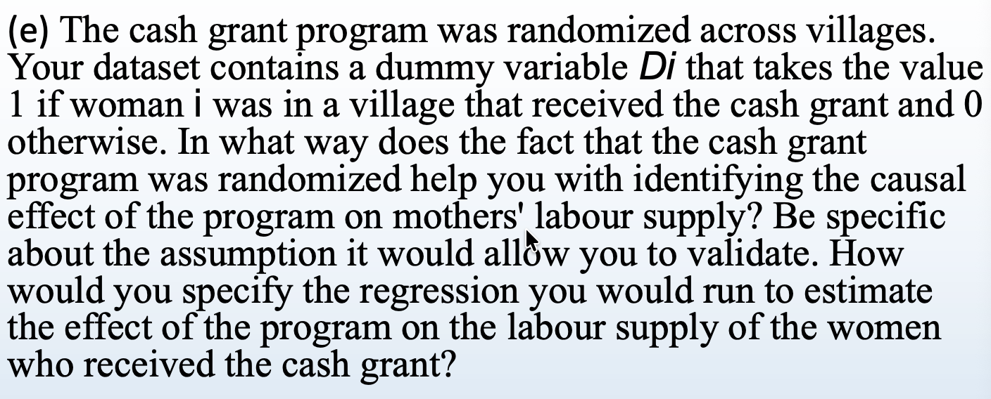
It is important to ensure there is no selection bias. The assumption is that before the treatment, the treatment group would act the same as the control group. Meaning that the mum who does not receive cash grant would act the same as the women in the population. Introduce a dummy variable of the treatment group, mother and receiving treatment E( Treatment =1 | xxx)

